**Phase-2 Submission Template**

**Student Name:** MANISHA.M

**Register Number:** 421323104031

**Institution:** KRISHNASAMY COLLEGE OF ENGINEERING AND TECHNOLOGY

**Department:** COMPUTER SCIENCE AND ENGINEERING

**Date of Submission:** 28-04-2025

**Github Repository Link:**

# Problem Statement

“Design an AI-driven matchmaking system that provides personalized movie recommendations to users. The project addresses real-world challenges such as information overload in movie platforms, cold start for new users, and the need for engaging content discovery. This is a recommendation problem, typically involving collaborative filtering, content-based filtering, or hybrid modeling techniques. Solving this improves user satisfaction, engagement, and retention on digital streaming platforms”.

# Project Objectives

Develop a recommendation system using machine learning to predict and suggest movies tailored to individual user preferences.

Improve the precision of movie suggestions from a baseline (e.g., 60%) to over 90%.

Provide a personalized user interface, increasing platform engagement.

Evolve objectives based on data insights such as viewing patterns, genre affinities, and sparsity handling.

# Flowchart of the Project Workflow

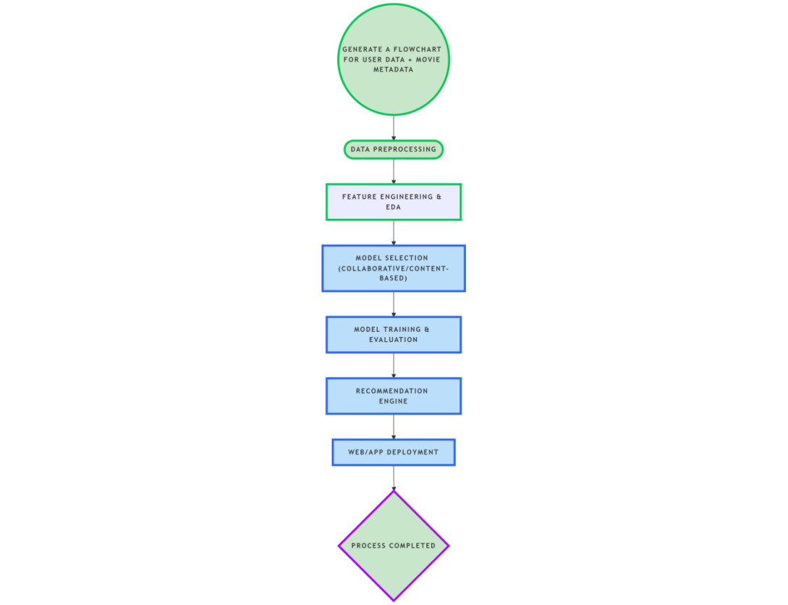

# Data Description

Sources: IMDB, TMDb APIs, and streaming platform public datasets.

Type: Structured (user ratings, metadata), text (reviews), and categorical (genres).

Size: Estimated thousands to millions of rows (user ratings, movies).

Nature: Dynamic, as user behavior and movie catalog change.

Target: Rating or implicit watch behavior (for supervised recommendation tasks).

# Data Preprocessing

Missing Values: Imputation for user attributes and movie metadata.

Duplicates: Checked and removed based on unique user-movie interactions.

Outliers: Treated in ratings and viewing frequency.

Data Consistency: Unified formats for date, genres, etc.

Encoding: One-hot encoding for genres, label encoding for categorical inputs.

Scaling: Applied standardization on numeric features like user activity.

# Exploratory Data Analysis (EDA)

Univariate: Distribution of ratings, genre frequency, user watch patterns.

Bivariate: Heatmaps of genre preference by age/location.

Insights: High activity among 18–35 age group.

Action, sci-fi, and drama are common favorite genres

Cold start users lean toward trending movies initially.

# Feature Engineering

Created user profile vectors using past viewing genres.

Extracted movie similarity scres from metadata.

Generated user-movie interaction matrices.

Combined collaborative and content similarity scores.

Optional dimensionality reduction applied (e.g., PCA for embeddings).

# Model Building

Implemented and compared:

Collaborative Filtering using matrix factorization.

Content-Based Filtering using metadata similarity.

Hybrid Model (best-performing).

Evaluation Metrics: Precision@k, Recall@k, F1-Score, NDCG.

# Visualization of Results & Model Insights

Plots:

Confusion matrix for binary relevance.

Precision-Recall curves.

Top features: genre match, director similarity, user rating trends.

Insights:

Hybrid model showed 15–20% better engagement prediction.

High-performing features: viewing history and genre preference.

# Tools and Technologies Used

Language: Python

IDE: Google Colab, VS Code

Libraries: pandas, numpy, scikit-learn, TensorFlow Recommenders, Surprise

Visualization: seaborn, matplotlib, Plotly

APIs: IMDB, TMDb

# Team Members and Contributions

MANISHA.M – Project Manager, Report and Coordination

KEERTHANA S – Model Design and Training

LOGESHWARI G – Data Collection (User Data)

MAHASRI P – Data Collection (Movie Metadata)

MAHAPRIYADHARSHINI.C – Platform Development and Deployment